
General Sir John Kotelawala Defense University, Sri Lanka Faculty Of Engineering

ET3112 Assignment 02

Student Name : R.M.S.D.Rathnayaka
Registration Number : D/ENG/24/0153/EE
Instructed By : Dr. Sampath Perera
Stream/Intake : Intake 41
Module Code/Name : ET3112-Image Processing and Machine Vision
Date Of Submission : 20.03.2026
Github Link :

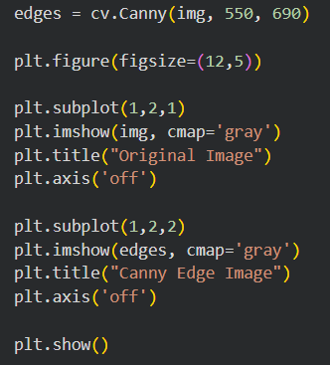
1)

indices = np.where(edges != 0)
x = indices[1]
y = indices[0]

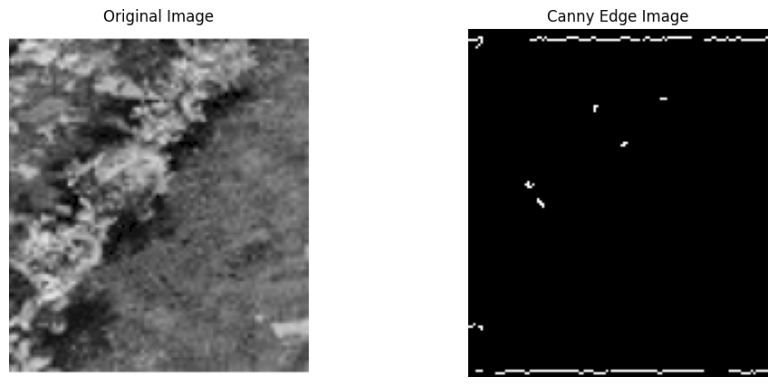
2)
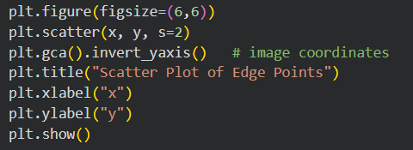

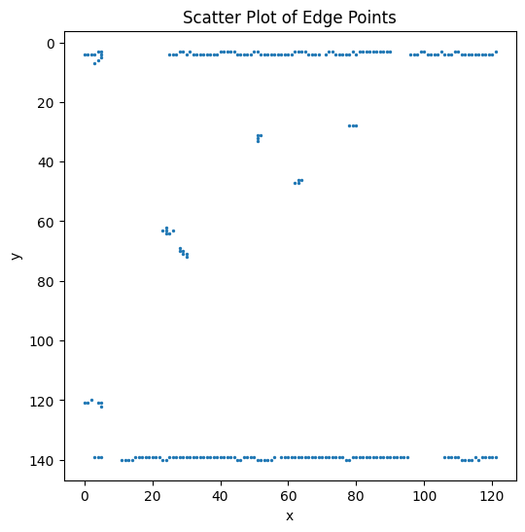

3)
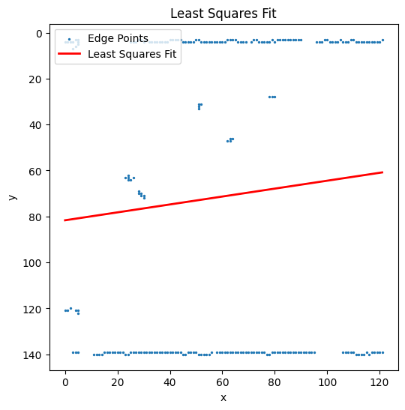
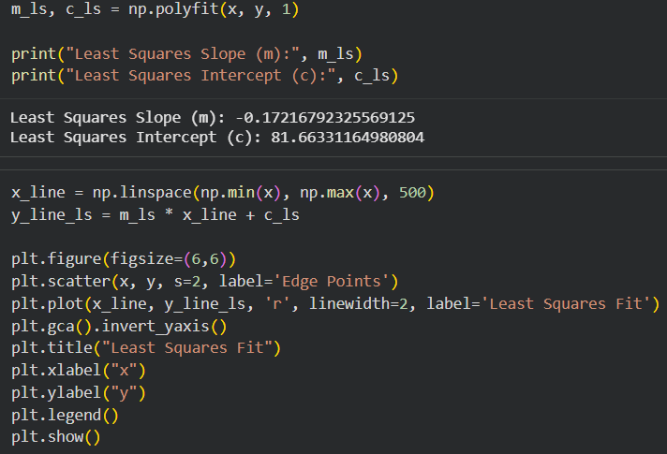
4)
Calculate angle
θ=tan⁻¹(m)
θ=tan⁻¹(0.1721679)
θ= 9.78∘
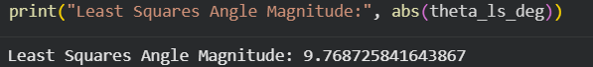
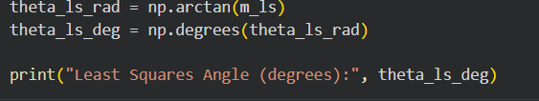
5)

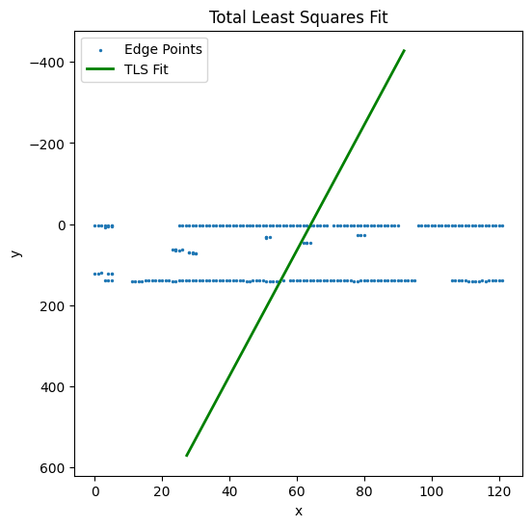
No, the estimation is not correct. The least-squares-fit method is sensitive to noise and outliers in the edge image. The Canny edge detector extracts not only the main crop boundary but also many unwanted edge points from background texture and vegetation. Since least squares minimizes the sum of squared vertical errors, these irrelevant points influence the fitted line strongly and pull it away from the true crop boundary. As a result, the estimated angle becomes inaccurate.
6)
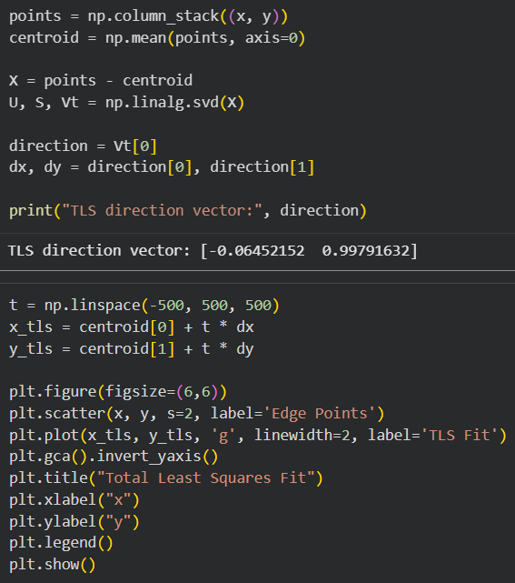

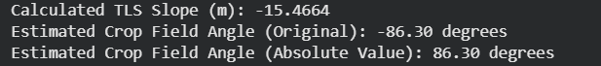
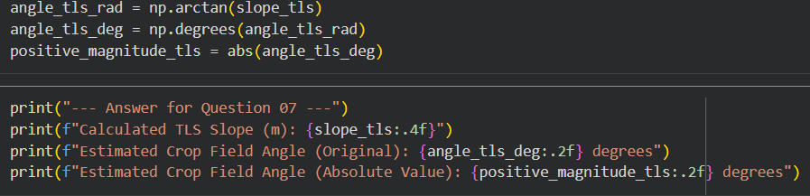
7)

8)
No, the total least-squares estimation is still not correct. Although TLS is better than ordinary least squares because it minimizes the perpendicular distance from the points to the fitted line, it still uses all detected edge points in the calculation. The edge image contains many noisy points and unwanted background edges that do not belong to the actual crop boundary. These outliers influence the fitted line and make the estimated angle inaccurate. This is why the TLS result became very large and close to a vertical line

A better algorithm for this scenario is the Random Sample Consensus (RANSAC) method. RANSAC is a robust algorithm used to estimate a mathematical model from a dataset that contains a large number of outliers. Instead of using all data points, it randomly selects a small subset of points to estimate a model and then checks how many other points agree with that model (inliers). Points that do not fit are ignored as outliers. This process is repeated multiple times, and the model with the highest number of inliers is selected as the best fit. Therefore, RANSAC is more suitable for this scenario because it effectively removes the influence of noisy edge points and provides a more accurate estimation of the crop field boundary.
9)

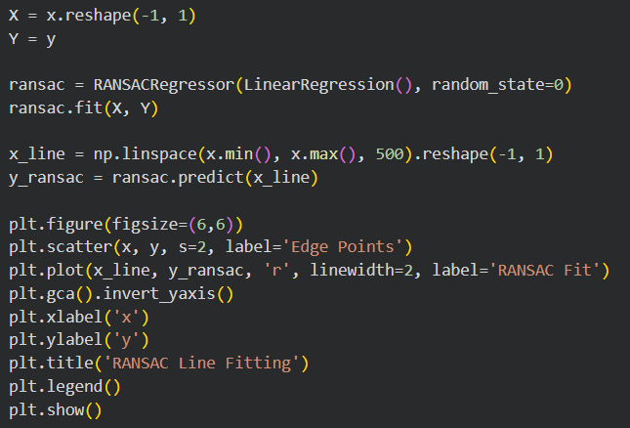
10)

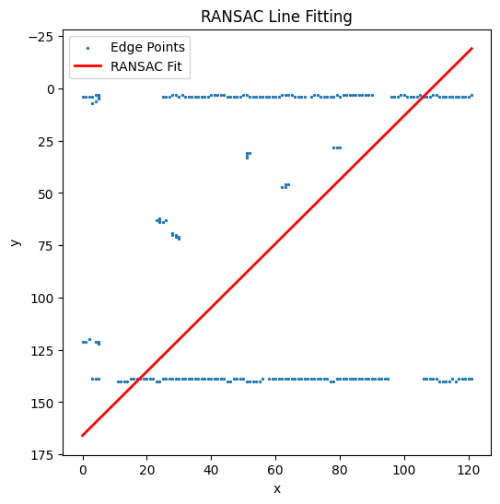

11)
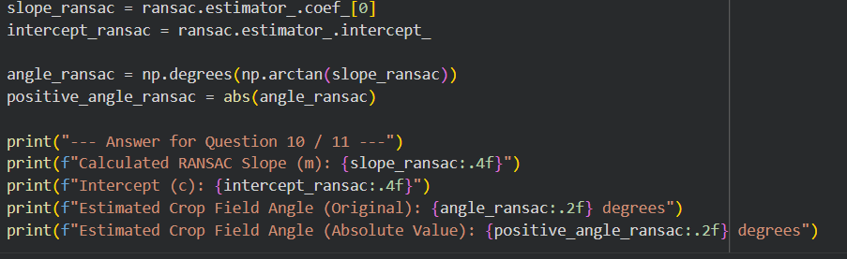
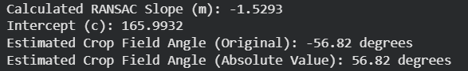
12)
The RANSAC method performs better than both LS and TLS because it is specifically designed to handle datasets with a large number of outliers. In this problem, the edge image contains many unwanted edge points caused by background textures, soil patterns, and vegetation, which do not belong to the actual crop boundary.
Both LS and TLS use all available data points to estimate the line. As a result, noisy and irrelevant points significantly influence the fitted model, causing the estimated line to deviate from the true crop boundary. LS minimizes vertical errors, while TLS minimizes perpendicular errors, but neither method can ignore outliers.
In contrast, RANS AC works by randomly selecting small subsets of points to generate candidate lines and then evaluating how many points agree with each line (inliers). Points that do not fit within a defined threshold are treated as outliers and ignored. By repeating this process multiple times, RANSAC identifies the line with the highest number of inliers, which represents the dominant crop boundary.
Therefore, RANSAC provides a more accurate and reliable estimation because it effectively reduces the impact of noise and focuses only on the meaningful edge points.

